UMSI Board Meeting
May 23, 2023

UMSI Board Meeting May, 2023

Board Members Present: Jessica Davis, Kathy Lause, Vyju Kadambi, Greg Brubaker, Ines Oldenburg, Katie Gerdts, Tiffany Fennig
Absent: Laurie Stockton-Moreno
Additional guests: Laticia Bleck, Laura Hayden, Andrea Preston, Sandra Deacon
Opening
Quick introduction of all board members and guests
- Jess reads the UMSI Mission Statement.
  - Mission Statement: With integrity, United Montessori Schools of Indiana fosters a community that supports, unifies, and advocates for the advancement of Montessori education.
- Consent of minutes approved

Treasurer’s Report
- Kathy will send Quickbooks reports with minutes.
- Moving from a static budget to working budget
Budget plans have been submitted; Membership is still missing
Kathy is giving us a summarized budget for all committees by Memorial Day and we can have a first reading via email with EVERYONE responding by July 10th. Mark your calendars!!!
  - Discussion of operating budget/committee budget proposals
Amounts that are spent from the approved budget need approval from all the committee members; additional funding outside of approved budget, has to be board approved
  - Discussion on expenditure limit without board approval

General Items
- Strategic Plan Final Draft Review/Possible vote (Jess)
  - UMSI Strategic Plan Final Draft 2023 Motion by Kathy to accept this strategic plan as written; seconded by Kathy; other votes: Vyju yes, Tiffany obstain, Teresa yes, Greg yes, Ines Yes, Katie yes, Jess yes
- Board Liability Insurance (Greg) Greg worked with insurance provider and they are not binding quotes but reliable estimates
- Jess send it to her school’s provider for second quote
- The Cincinnati Insurance seems most affordable
- Vyju make smotion to purchase insurance as written out, Kathy seconded the motion; Other votes: Kathy yes, Katie yes, Tiffany yes, Vyju yes, Teresa yes, Greg yes, Ines yes, Jess yes
- Greg is in touch with Kathy for the purchase
  - Affordable?
    - Cincinnati Insurance's non-binding quotes for coverage are as follows: (a) $704 for $500,000 in coverage; (b) $880 for $1,000,000 in coverage; and (c) $1,340 for $2,000,000 in coverage. They can only provide binding quotes after we complete the application.
    - ML007 EME (new) (002).pdf
- Promo for free membership through October 1
See membership update

Membership
- budget: needs would fall under "marketing" and we're not sure what we'd need beyond a possible social media "sponsored content" situation so we'll re-address if necessary for something like the fall conference
- need to get started with pricing and benefits package. we meet June 22 at 7 pm and would love to have your input, so join us if you have ideas and opinions (would be helpful to have a sense of the history here, who can help?) survey goes out on June 16th
- Confirming: the list of people signing up for the free membership is only contained in the form?
- link to free membership: is it intuitive/easy to find? Please check 52 people have signed up for free membership so far
- Census cold calls, Language for membership (added to doc, free until October, will send specific info with conference info)**can register as school or as individual
- membership survey being sent 6/16
- Should we consider some additional social media presence when we roll out the new membership information (something like a countdown?)

  - 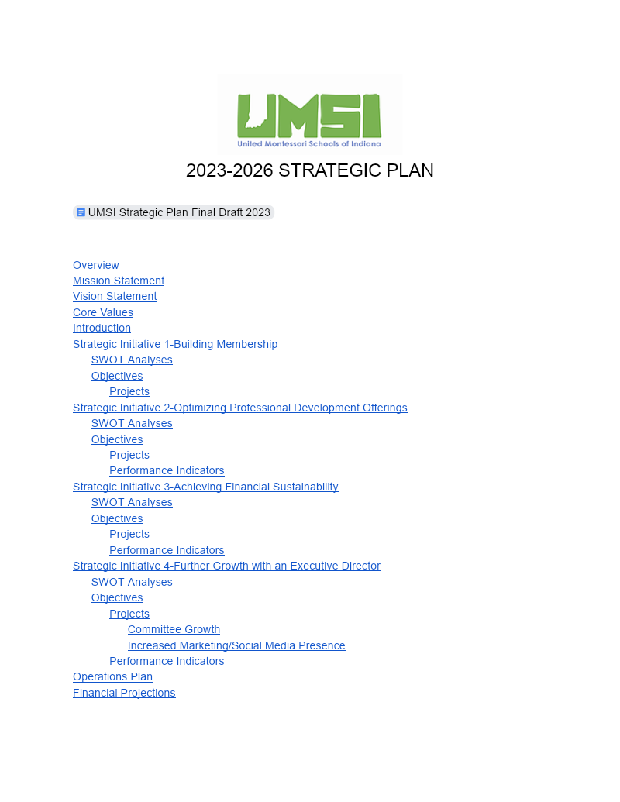Free UMSI membership promotion draft
    - “Exclusive early registration” for fundamentals
    - Networking events
    - Surveys
  - Free Membership Registration Form
- School outreach project (inter-committee initiative)
  - 2023 UMSI Montessori School Outreach and Census
    - Have we settled who will call each school?
  - Talking Points for School Calls
    - Membership rate hike?
      - UMSI-Individual $35, Schools $50-200
      - Michigan-individuals $20, adult learners free, schools $40
      - Ohio-no organization
      - Illinois-No individual memberships, school memberships $100-150
      - Kentucky-$25 Individual, Schools $50-200
    - Validation rate hike?
      - UMSI-$100 per level
      - Maryland $100 (per school?)
      - Washington $100 (per school?)
      - Colorado $150
    - Info for individual membership for schools to share with staff
    - Census form
      - Laurie has designed a survey that can collect membership survey data and census data at the same time

Committee Updates
- Membership (Teresa)
  - Actions during “free membership through October 1”
    - Member survey out to anyone on old lists
    - Promotion of free membership to mail chimp contacts and social media contacts
    - Build database of current members from Google form submissions
    - Launch updated benefit package (based on survey) with re-enrollment (September 1?) to all free members plus all mail chimp and social media contacts
    - Billing and payment follow-up September 1-October (so that they will be official members for conference registration)
- Professional Development (Vyju)
  - Conference has not met this month
  - Fundamentals (IPS) drafted budget
  - Fundamentals (Public) all advertisement and sign-up links are live and we have all presenters organized; currently no sign-ups but we are hopeful that things will move forward as we are closing the school year.
Quick reminder that we decided to pay a consultant to organize and advertise for the conference (George Markham)--> see last meeting minutes
- Governance (Laurie)
  - Will create census form to send out with school outreach (outreach will begin census data collection), then follow up to complete census to most accurate possible currently 60 schools, Jess is reaching out to non-licensed schools to see if they would like to be validated
  - Is there anyone not on Governance who is willing to help with this project (the nagging and follow-up)? please reach out to Jess or Laurie if you would like to help
  - Jess filled in the missing schools with names of board members to call
  - July 3rd is deadline for the calls
  - Talking points are found in this agenda (see above)
  - Vyju is sorting the document

Other Business
- Set more meetings
  - Teresa, please publish list on website.
  - Use of personal meeting room link (umsizoom@gmail.com) for website link listings?

Next BOD meetings: – Dates/Times

July 16, 2023
September 17th
November 12th
January 21st

