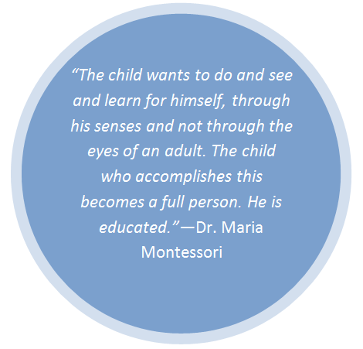

In a Montessori classroom, the trained teacher is the link between the carefully prepared environment and the children. So, collaborative teamwork between the lead teacher and assistant are vital. Here at MSW, an assistant teacher in the classroom is expected to:

* Work cohesively with the lead teacher to provide educational instruction and guidance to the children
* Have a basic understanding of Montessori philosophy and terminology
* Aid the lead teacher in the preparation of the environment on a daily basis
  + Make sure each activity is beautiful, complete, and prepared for children’s independent use
  + Maintain supplies for the classroom
  + Maintain the indoor and outdoor environment
* Observe and record the children’s progress
* Adhere to MSW’s safety guidelines and requirements
* Foster supportive relationships with the parent community and school community at large
* Support the lead teacher in communications with parents
* Be present at all MSW functions that may occur after school hours, including, but not limited to:
  + Parent education nights
  + Open houses
  + Spring program
  + Graduation
* Be a team player 